**Hand Gesture Recognition Using Mediapipe**

**A PROJECT REPORT**

**Submitted By**

**SRISHTY SINGH**

**(2100290140136 )**

**RAJ PRATAP SINGH**

**(2100290140109 )**

**Submitted in partial fulfilment of the**

**Requirements for the Degree of**

**MASTER OF COMPUTER APPLICATION**

**Under the Supervision of**

**Mr. Prashant Agrawal**

### Associate Professor



**Submitted to**

**Department Of Computer Applications**

**KIET Group of Institutions, Ghaziabad**

**Uttar Pradesh-201206**

**( 15 Dec 2022)**

**CERTIFICATE**

Certified that **Srishty Singh (2100290140136), Raj Pratap Singh (2100290140109)** have carried out the project work having “**Hand Gestures Recognition Using Mediapipe**” for Master of Computer Applications from Dr. A.P.J. Abdul Kalam Technical University (AKTU**)** (formerly UPTU), Technical University, Lucknow under my supervision. The project report embodies original work, and studies are carried out by the students themselves and the contents of the project report do not form the basis for the award of any other degree to the candidate or to anybody else from this or any other University/Institution.

**Date: Srishty Singh (2100290140136)**

**Raj Pratap Singh (2100290140109)**

This is to certify that the above statement made by the candidate is correct to the best of my knowledge.

**Date: Mr. Prashant Agrawal**

**Associate Professor**

**Department of Computer Applications**

**KIET Group of Institutions, Ghaziabad**

**Signature of Internal Examiner Signature of External Examiner**

**Dr. Arun Tripathi**

**Head, Department of Computer Applications**

**KIET Group of Institutions, Ghaziabad**

**ABSTRACT**

The project performs Hand Gesture Recognition, making use of Google's Mediapipe framework in python, without any physical aid being affixed to hands.

MediaPipe offers customizable ML solutions. Mediapipe Hands is a hand and finger tracking solution. It works by deducing 21 3D landmarks of a hand. For which the pipeline consists of two modules: a palm detection model after that a hand landmark model. The palm detector achieves an average precision of 95.7%. The hand detector performs key-point localization of all 21 hand-knuckle coordinates in the detected hand regions provided by palm detector employing regression.

The project captures live video feed from camera using opencv library then pass it to Mediapipe that returns the landmarks' details. Afterwards it operate on those landmarks to implement several trivial use cases. By computing relative positioning, distance among landmarks, linear alignment we implement virtual mouse, finger counter, volume controller, rock-paper-scissors game. The required GUI is brought about using opencv.

**ACKNOWLEDGEMENT**

Success in life is never attained single handedly. My deepest gratitude goes to my thesis supervisor, **Mr. Prashant Agrawal** for his guidance, help and encouragement throughout my research work. Their enlightening ideas, comments, and suggestions.

Words are not enough to express my gratitude to Dr. Arun Kumar Tripathi, Professor and Head, Department of Computer Applications, for his insightful comments and administrative help at various occasions.

Fortunately, I have many understanding friends, who have helped me a lot on many critical conditions.

Finally, my sincere thanks go to my family members and all those who have directly and indirectly provided me moral support and other kind of help. Without their support, completion of this work would not have been possible in time. They keep my life filled with enjoyment and happiness.

**Srishty Singh (2100290140136)**

**Raj Pratap Singh (2100290140109)**

**TABLE OF CONTENTS**

|  |  |  |  |
| --- | --- | --- | --- |
|  | Certificate | | i |
|  | Abstract | | ii |
|  | Acknowledgement | | iii |
|  | Table of Contents | | iv |
| 1. | Introduction | | 6-9 |
|  | 1.1 | Project Description | 6-7 |
|  | 1.2 | Project Methodology | 8 |
|  | 1.3 | Hardware / Software used | 9 |
| 2 | Feasibility Study | | 10 |
|  | 2.1 | Technical Feasibility | 10 |
|  | 2.2 | Operational Feasibility | 10 |
|  | 2.3 | Economical Feasibility | 10 |
| 3 | Design (Input/Output Screenshots) | | 11-16 |
|  | 3.1 | Hand Tracking | 11 |
|  | 3.2 | Finger Counter | 12 |
|  | 3.3 | Virtual Mouse Pointer | 13 |
|  | 3.4 | Volume Controller | 14 |
|  | 3.5 | Rock-Paper-Scissors Game | 15 |
|  | 3.6 | Snake Game | 16 |
| 4 | Coding | | 17-30 |
| 5 | Comparison | | 31 |
| 6 | Limitations | | 32 |
| 7 | Conclusion | | 33 |
| 8 | Future Scope | | 34 |
| 9 | Bibliography | | 35-37 |
|  |  | |  |

**INTRODUCTION**

**1.1 PROJECT DESCRIPTION**

**What is Gesture Recognition?**

Gesture recognition is the mathematical interpretation of a human hand motion by a computing device. It is a sub-discipline of computer vision.

Gesture recognition is a type of perceptual computing user interface that allows computers to capture and interpret human gestures as commands. The general definition of gesture recognition is the ability of a computer to understand gestures and execute commands based on those gestures. Users can make simple gestures to control or interact with devices without physically touching them.

Gesture recognition can be seen as a way for computers to begin to understand human body language, thus building a better bridge between machines and humans than older text user interfaces or even GUIs (graphical user interfaces), which still limit the majority of input to keyboard and mouse and interact naturally without any mechanical devices.

**What is Mediapipe Hands?**

MediaPipe Hands is a high-fidelity hand and finger tracking solution. It employs machine learning (ML) to infer 21 3D landmarks of a hand from just a single frame. Whereas current state-of-the-art approaches rely primarily on powerful desktop environments for inference, this method achieves real-time performance on a mobile phone, and even scales to multiple hands.

MediaPipe Hands utilizes an ML pipeline consisting of multiple models working together: A palm detection model that operates on the full image and returns an oriented hand bounding box. A hand landmark model that operates on the cropped image region defined by the palm detector and returns high-fidelity 3D hand keypoints.

**Palm Detection Model :** This trains a palm detector instead of a hand detector, since estimating bounding boxes of rigid objects like palms and fists is significantly simpler than detecting hands with articulated fingers. It achieves an average precision of 95.7% in palm detection.

**Hand Landmark Model :** After the palm detection over the whole image our subsequent hand landmark model performs precise keypoint localization of 21 3D hand-knuckle coordinates inside the detected hand regions via regression, that is direct coordinate prediction. The model learns a consistent internal hand pose representation and is robust even to partially visible hands and self-occlusions.

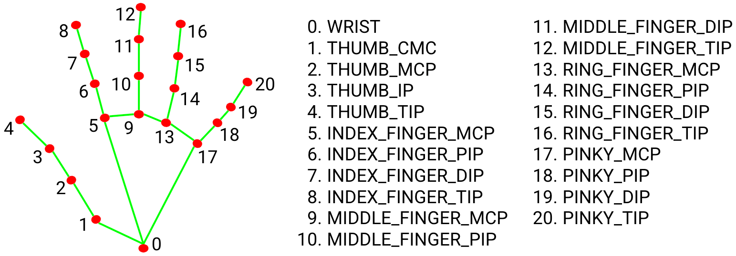

**Implementation**

Afterwards operating on the landmarks provided by the model, project implements several trivial use cases, by computing relative positioning, distance among landmarks, linear alignment.

Applications implemented in the project are:

* Virtual mouse pointer with left click operation.
* Volume controller
* Finger counter for 0-5 in right-hand
* Rock-Paper-Scissors game with AI as opponent
* Snake game

**1.2 PROJECT METHODLOGY**

1. **MediaPipe-** MediaPipe is an artificial intelligence framework provided by Google. This is a service that provides a solution-type library so that the human body recognition function model included in the image data can be developed and learned and used easily. MediaPipe's representative solutions are configured as shown in Table 2, and continue to provide new solutions. MediaPipe supports various development environments such as web pages, Android, and iOS. And supported languages include Android, iOS, C++, Python, JS, and Coral. In addition, the media pipe is an opensource project, and the program source is disclosed, so you can modify what you want and use it for development. In this study, the Hands solution, which recognizes the shape and movement of the hand among the MediaPipe solutions, was used.
2. **Mediapipe and Hand tracking-** MediaPipe hand tracking is a model that uses a machine learning pipeline to detect and track recognized hands and fingers in images. After detecting the palm of the entire image using machine learning, as shown in Figure 1, the method uses a method of mapping 21 coordinates to define 3D coordinates to display the joints of the palm and obtain real data. MediaPipe hand tracking provides real-time performance that Han et al, Journal of System and Management Sciences, Vol. 12 (2022) No. 2, pp. 462-476 467 can be used not only on desktop computers but also on smartphones, and can be expanded to recognize multiple hands at once.
3. **ML Pipeline-** MediaPipe Hands utilizes a multi-model ML pipeline. Representative examples are the palm detection model, which operates on the entire image and returns an oriented hand bounding box, and the hand landmark model, which operates on the cropped image region defined by the palm detector and returns high-fidelity 3D hand keypoints.

**1.3 HARDWARE / SOFTWARE USED**

**Hardware Used :**

1. Mainframe - Intel core i5 ninth generation.
2. Python put in Windows Os or Linux Os Machine
3. GPU - Nvidia GTX 1050 Ti.
4. 720p60 net Camera

**Software Used :**

1. Windows Os or Linux Os
2. Python 3
3. Open-Cv
4. Mediapipe
5. Tensorflow
6. Pycharm Code Editor

**FEASIBILITY STUDY**

**2.1 Technical Feasibility**

* The basic hardware requirement of this project is a camera which can be easily found in any system or availed individually.
* It doesn’t require high processing power so it can run on all machines.
* The basic software requirement of this project is some libraries which can be easily installed from the internet.

The above points conclude that the project is technically feasible to be developed.

**2.2 Operational Feasibility**

* The main purpose of building this project is to minimize the usage of input hardware like mouse and keyboard to interact with the system.
* It provides an innovative idea to use hand gestures to interact with the system instead of input devices.

The above points concludes that the project is operationally feasible to be developed.

**2.3 Economical Feasibility**

* The basic hardware requirement of this project is a camera which can be easily found in any system. So, there is no cost requirement for any external hardware..
* It doesn’t require high processing power so it can run on all machines.
* The basic software requirement of this project is some libraries which can be easily installed from the internet. Those libraries are free of cost.

The above points concludes that the project doesn’t require any extra cost to be developed. Hence, It is economically feasible.

**DESIGN**

**3.1 Hand Tracking**

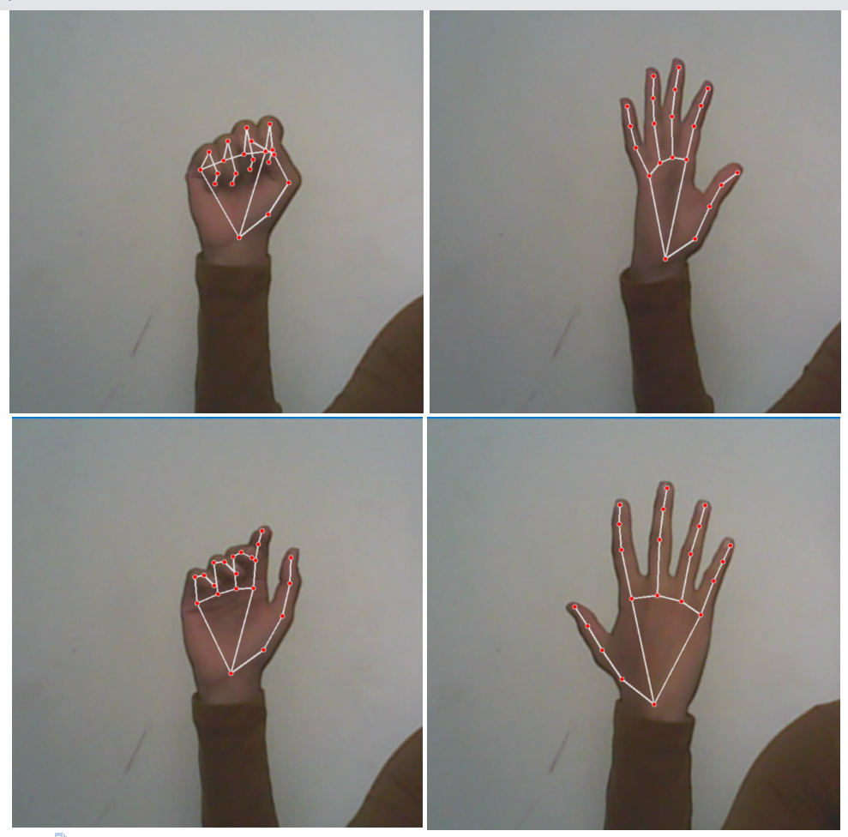

Hand tracking is the process of detecting and tracking the movements and gestures of the human hand in real-time using camera feed. Hand tracking has many applications in fields such as virtual reality, gaming, robotics, human-computer interaction, and sign language recognition.

**3.2 Finger Counter**

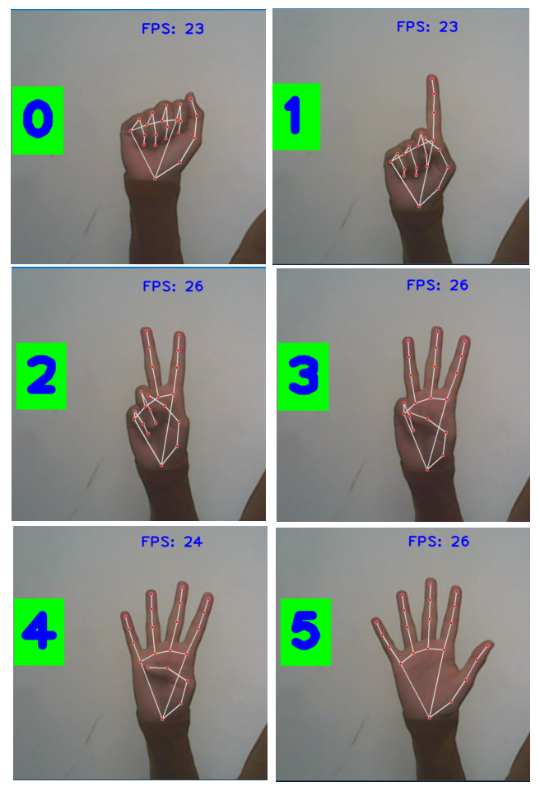

**3.3 Virtual Mouse Pointer**

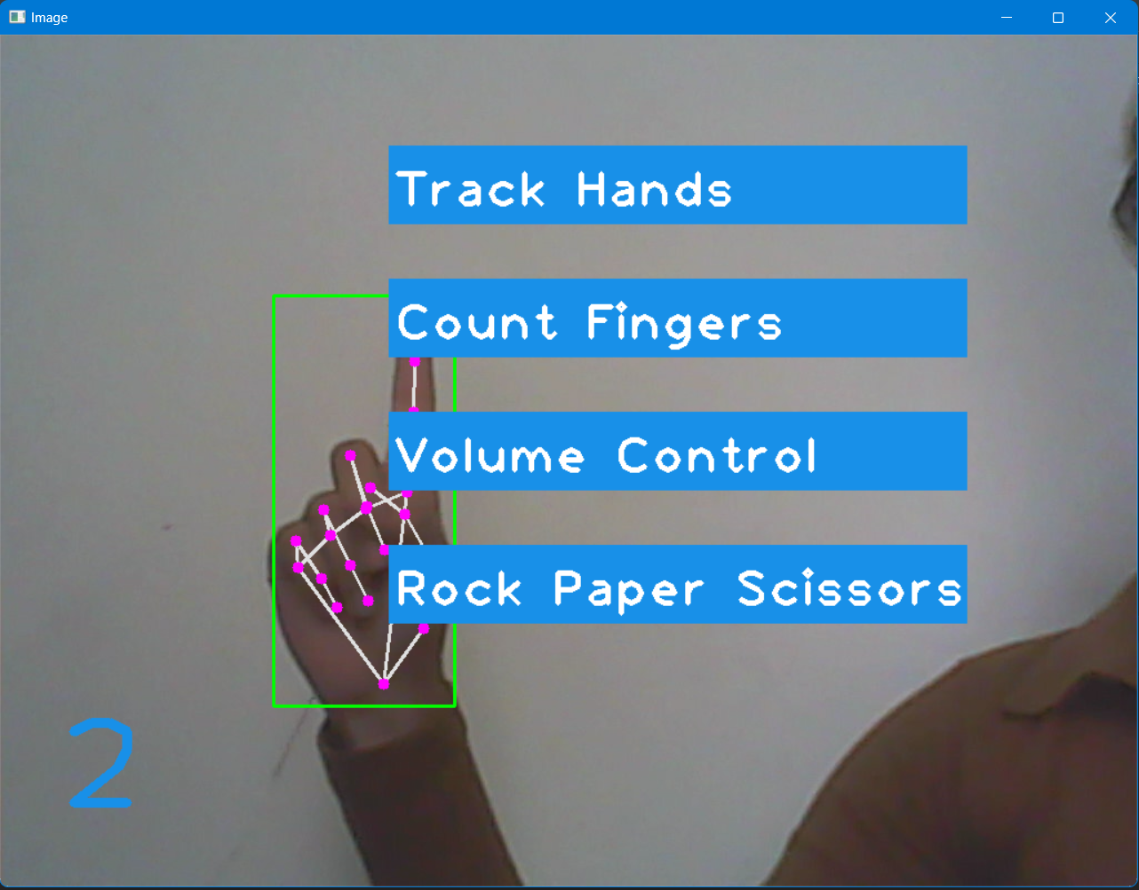

A virtual mouse pointer enables users to control the movement of the mouse pointer on their computer screen without using a physical mouse. Virtual mouse pointers are particularly useful for individuals who have mobility impairments or who prefer alternative input devices to a traditional mouse.

**3.4 Volume Controller**

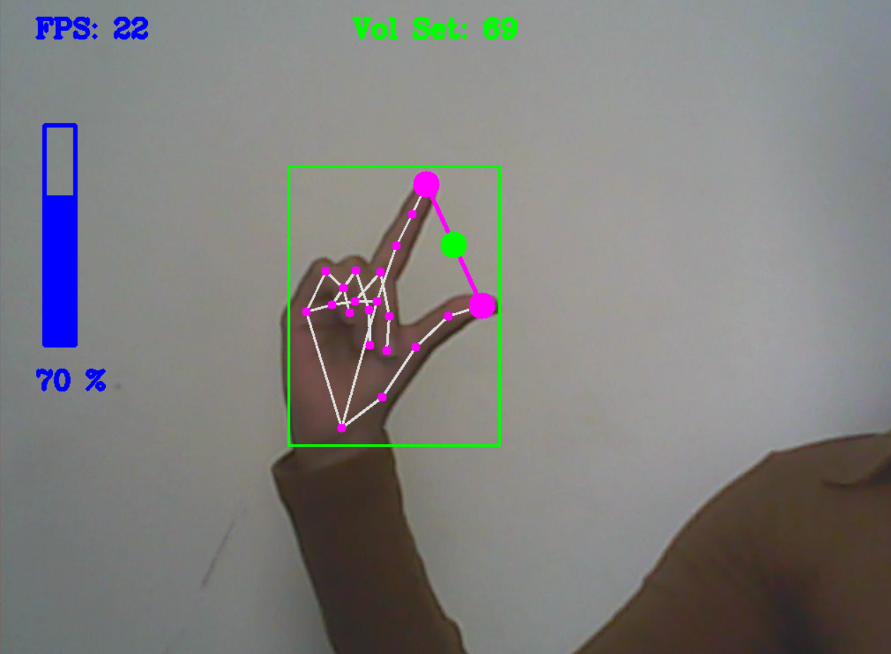

Volume controller enables users to control their system’s output volume using simple

hand gestures. Volume control using hand gestures is particularly useful in situations where users may not have direct access to their devices, such as when listening to music or watching a video from a distance, or when their hands are occupied with other tasks.

**3.5 Rock-Paper-Scissors Game**

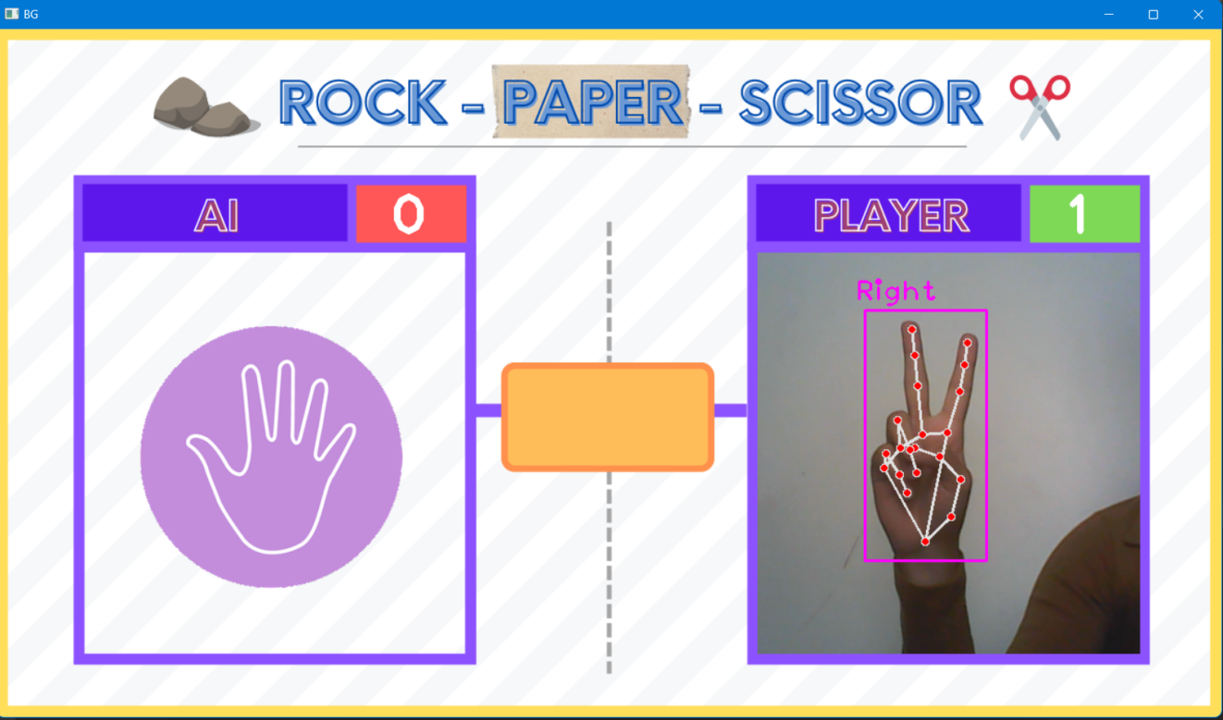

User can also play some games like Rock-Paper-Scissors and Snake game using with simple hand gestures. Both the games are interactive. Many more games can be played using hand gesture which enables hand gesture recognition to be a very innovative technology in the filed of game development.

**3.6 Snake Game**

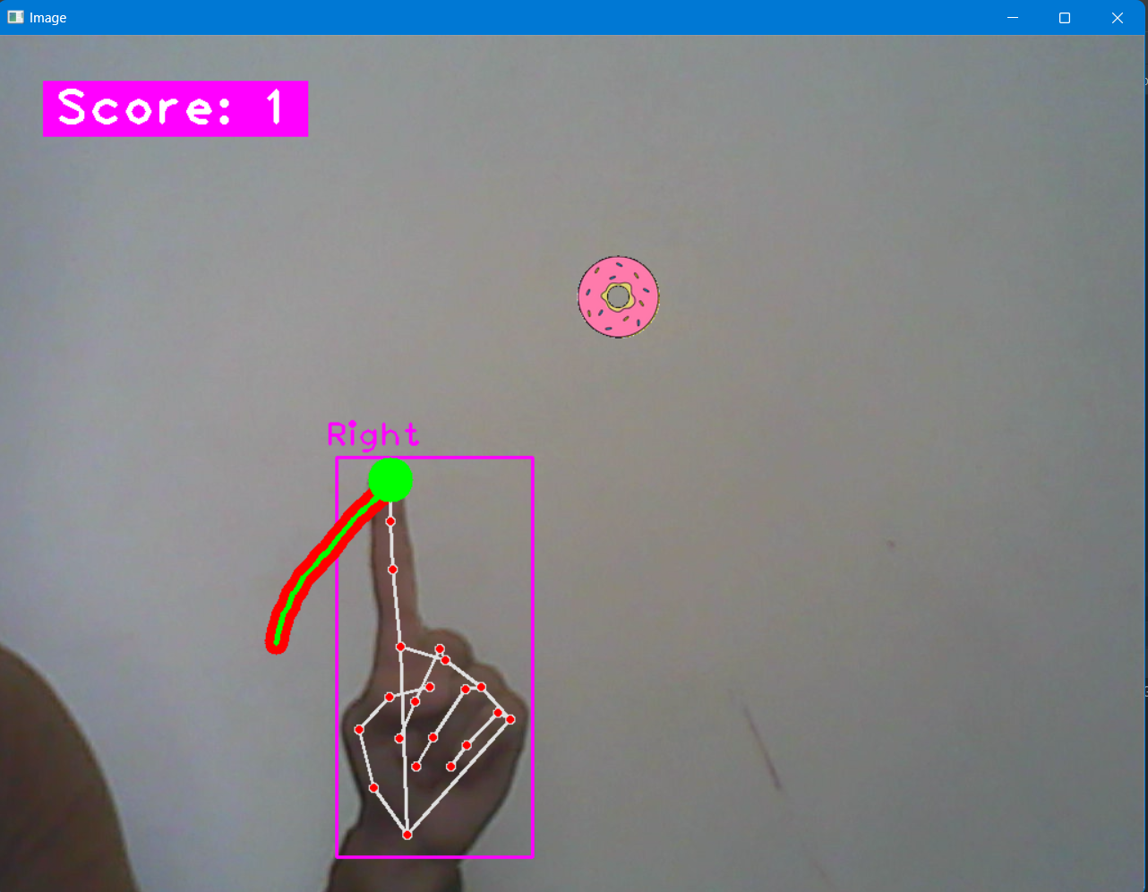

**CODING**

**4.1 HandTrackingModule.py**

import cv2  
import mediapipe as mp  
import time  
import math  
  
  
class HandDetector():  
 def __init__(self, mode=False, maxHands=2, model_complexity=1, detectionCon=0.5, trackCon=0.5):  
 self.mode = mode  
 self.maxHands = maxHands  
 self.detectionCon = detectionCon  
 self.trackCon = trackCon  
 self.model_complexity = model_complexity  
  
 self.mpHands = mp.solutions.hands  
 self.hands = self.mpHands.Hands(self.mode, self.maxHands, self.model_complexity,  
 self.detectionCon, self.trackCon)  
 self.mpDraw = mp.solutions.drawing_utils  
 self.tipIds = [4, 8, 12, 16, 20]  
  
  
 def findHands(self, img, draw=True):  
 imgRGB = cv2.cvtColor(img, cv2.COLOR_BGR2RGB)  
 self.results = self.hands.process(imgRGB)  
 *# print(results.multi_hand_landmarks)* if self.results.multi_hand_landmarks:  
 for handLms in self.results.multi_hand_landmarks:  
 if draw:  
 self.mpDraw.draw_landmarks(img, handLms, self.mpHands.HAND_CONNECTIONS)  
 return img  
  
 def findPositionVol(self, img, handNo=0, draw=True):  
 xList = []  
 yList = []  
 bbox = []  
 self.lmList = []  
 if self.results.multi_hand_landmarks:  
 myHand = self.results.multi_hand_landmarks[handNo]  
 for id, lm in enumerate(myHand.landmark):  
 *# print(id, lm)* h, w, c = img.shape  
 cx, cy = int(lm.x * w), int(lm.y * h)  
 xList.append(cx)  
 yList.append(cy)  
 *# print(id, cx, cy)* self.lmList.append([id, cx, cy])  
 if draw:  
 cv2.circle(img, (cx, cy), 5, (255, 0, 255), cv2.FILLED)  
 xmin, xmax = min(xList), max(xList)  
 ymin, ymax = min(yList), max(yList)  
 bbox = xmin, ymin, xmax, ymax  
  
 if draw:  
 cv2.rectangle(img, (bbox[0] - 20, bbox[1] - 20),  
 (bbox[2] + 20, bbox[3] + 20), (0, 255, 0), 2)  
  
 return self.lmList, bbox  
  
  
 def findPosition(self, img, handNo=0, draw=True):  
  
 lmList = []  
 if self.results.multi_hand_landmarks:  
 myHand = self.results.multi_hand_landmarks[handNo]  
 for id, lm in enumerate(myHand.landmark):  
 *# print(id, lm)* h, w, c = img.shape  
 cx, cy = int(lm.x * w), int(lm.y * h)  
 *# print(id, cx, cy)* lmList.append([id, cx, cy])  
 if draw:  
 cv2.circle(img, (cx, cy), 15, (255, 0, 255), cv2.FILLED)  
  
 return lmList  
  
  
 def fingersUp(self):  
 fingers = []  
 *# Thumb* if self.lmList[self.tipIds[0]][1] > self.lmList[self.tipIds[0] - 1][1]:  
 fingers.append(1)  
 else:  
 fingers.append(0)  
 *# 4 Fingers* for id in range(1, 5):  
 if self.lmList[self.tipIds[id]][2] < self.lmList[self.tipIds[id] - 2][2]:  
 fingers.append(1)  
 else:  
 fingers.append(0)  
 return fingers  
  
  
 def findDistance(self, p1, p2, img, draw=True):  
 x1, y1 = self.lmList[p1][1], self.lmList[p1][2]  
 x2, y2 = self.lmList[p2][1], self.lmList[p2][2]  
 cx, cy = (x1 + x2) // 2, (y1 + y2) // 2  
  
 if draw:  
 cv2.circle(img, (x1, y1), 15, (255, 0, 255), cv2.FILLED)  
 cv2.circle(img, (x2, y2), 15, (255, 0, 255), cv2.FILLED)  
 cv2.line(img, (x1, y1), (x2, y2), (255, 0, 255), 3)  
 cv2.circle(img, (cx, cy), 15, (255, 0, 255), cv2.FILLED)  
  
 length = math.hypot(x2 - x1, y2 - y1)  
 return length, img, [x1, y1, x2, y2, cx, cy]  
  
  
def main():  
 pTime = 0  
 cap = cv2.VideoCapture(1)  
 detector = HandDetector()  
 while True:  
 success, img = cap.read()  
 img = detector.findHands(img)  
 lmList = detector.findPosition(img)  
 if len(lmList) != 0:  
 print(lmList[4])  
  
 cTime = time.time()  
 fps = 1 / (cTime - pTime)  
 pTime = cTime  
  
 cv2.putText(img, str(int(fps)), (10, 70), cv2.FONT_HERSHEY_PLAIN, 3,  
 (255, 0, 255), 3)  
  
 cv2.imshow("Image", img)  
 cv2.waitKey(1)  
  
  
if __name__ == "__main__":  
 main()

**4.2 FingerCounter.py**

import cv2  
import time  
import os  
  
import HandTrackingModule  
import HandTrackingModule as htm  
  
wCam, hCam = 1920, 1080  
  
cap = cv2.VideoCapture(0)  
cap.set(3, wCam)  
cap.set(4, hCam)  
  
pTime = 0  
  
detector = htm.HandDetector(detectionCon=0.75, maxHands=1)  
  
tipIds = [4, 8, 12, 16, 20]  
  
while True:  
 success, img = cap.read()  
 img = detector.findHands(img)  
 lmList = detector.findPosition(img, draw=False)  
 print(lmList)  
  
 if len(lmList) != 0:  
 fingers = []  
  
 *# Thumb* if lmList[tipIds[0]][1] > lmList[tipIds[0] - 1][1]:  
 fingers.append(1)  
 else:  
 fingers.append(0)  
  
 *# 4 Fingers* for id in range(1, 5):  
 if lmList[tipIds[id]][2] < lmList[tipIds[id] - 2][2]:  
 fingers.append(1)  
 else:  
 fingers.append(0)  
  
 *# print(fingers)* totalFingers = fingers.count(1)  
 print(totalFingers)  
  
 *#h, w, c = overlayList[totalFingers - 1].shape  
 #img[0:h, 0:w] = overlayList[totalFingers - 1]* cv2.rectangle(img, (20, 225), (170, 425), (0, 255, 0), cv2.FILLED)  
 cv2.putText(img, str(totalFingers), (45, 375), cv2.FONT_HERSHEY_PLAIN,  
 10, (255, 0, 0), 25)  
  
  
 cTime = time.time()  
 fps = 1 / (cTime - pTime)  
 pTime = cTime  
  
 cv2.putText(img, f'FPS: {int(fps)}', (400, 70), cv2.FONT_HERSHEY_PLAIN,  
 3, (255, 0, 0), 3)  
  
 cv2.imshow("Image", img)  
 cv2.waitKey(1)

**4.3 VirtualMouseMenu.py**

import cv2  
from HandTrackingModule import HandDetector  
from time import sleep  
import numpy as np  
import cvzone  
from pynput.keyboard import Controller  
  
cap = cv2.VideoCapture(0)  
cap.set(3, 1920)  
cap.set(4, 1080)  
  
detector = HandDetector(detectionCon=0.8)  
keys = [["Q", "W", "E", "R", "T", "Y", "U", "I", "O", "P"],  
 ["A", "S", "D", "F", "G", "H", "J", "K", "L", ";"],  
 ["Z", "X", "C", "V", "B", "N", "M", ",", ".", "/"]]  
finalText = ""  
  
keyboard = Controller()  
  
  
def drawAll(img, buttonList):  
 for button in buttonList:  
 x, y = button.pos  
 w, h = button.size  
 cvzone.cornerRect(img, (button.pos[0], button.pos[1], button.size[0], button.size[1]),  
 20, rt=0)  
 cv2.rectangle(img, button.pos, (x + w, y + h), (255, 0, 255), cv2.FILLED)  
 cv2.putText(img, button.text, (x + 10, y + 55),  
 cv2.FONT_HERSHEY_PLAIN, 4, (255, 255, 255), 4)  
 return img  
class Button():  
 def __init__(self, pos, text, size=[65, 65]):  
 self.pos = pos  
 self.size = size  
 self.text = text  
  
  
buttonList = []  
for i in range(len(keys)):  
 for j, key in enumerate(keys[i]):  
 buttonList.append(Button([100 * j + 50, 100 * i + 50], key))  
  
while True:  
 success, img = cap.read()  
 img = detector.findHands(img)  
 lmList, bboxInfo = detector.findPositionVol(img)  
 img = drawAll(img, buttonList)  
  
 if lmList:  
 for button in buttonList:  
 x, y = button.pos  
 w, h = button.size  
  
 if x < lmList[8][0] < x + w and y < lmList[8][1] < y + h:  
 cv2.rectangle(img, (x - 5, y - 5), (x + w + 5, y + h + 5), (175, 0, 175), cv2.FILLED)  
 cv2.putText(img, button.text, (x + 20, y + 65),  
 cv2.FONT_HERSHEY_PLAIN, 4, (255, 255, 255), 4)  
 l, _, _ = detector.findDistance(8, 12, img, draw=False)  
 print(l)  
  
 *## when clicked* if l < 30:  
 keyboard.press(button.text)  
 cv2.rectangle(img, button.pos, (x + w, y + h), (0, 255, 0), cv2.FILLED)  
 cv2.putText(img, button.text, (x + 20, y + 65),  
 cv2.FONT_HERSHEY_PLAIN, 4, (255, 255, 255), 4)  
 finalText += button.text  
 sleep(0.15)  
  
  
 cv2.rectangle(img, (50, 350), (700, 450), (175, 0, 175), cv2.FILLED)  
 cv2.putText(img, finalText, (60, 430),  
 cv2.FONT_HERSHEY_PLAIN, 5, (255, 255, 255), 5)  
 cv2.imshow("Image", img)  
 cv2.waitKey(1)

**4.4 VolumeController.py**

import cv2  
import time  
import numpy as np  
import HandTrackingModule as htm  
import math  
from ctypes import cast, POINTER  
from comtypes import CLSCTX_ALL  
from pycaw.pycaw import AudioUtilities, IAudioEndpointVolume  
  
*################################*wCam, hCam = 1920, 1080  
*################################*cap = cv2.VideoCapture(0)  
cap.set(3, wCam)  
cap.set(4, hCam)  
pTime = 0  
  
detector = htm.HandDetector(detectionCon=0.7, maxHands=1)  
  
devices = AudioUtilities.GetSpeakers()  
interface = devices.Activate(  
 IAudioEndpointVolume._iid_, CLSCTX_ALL, None)  
volume = cast(interface, POINTER(IAudioEndpointVolume))  
*# volume.GetMute()  
# volume.GetMasterVolumeLevel()*volRange = volume.GetVolumeRange()  
minVol = volRange[0]  
maxVol = volRange[1]  
vol = 0  
volBar = 400  
volPer = 0  
area = 0  
colorVol = (255, 0, 0)  
  
while True:  
 success, img = cap.read()  
  
 *# Find Hand* img = detector.findHands(img)  
 lmList, bbox = detector.findPositionVol(img, draw=True)  
 if len(lmList) != 0:  
  
 *# Filter based on size* area = (bbox[0] * bbox[1]) // 100  
 *# print(area)* if 250 < area < 1000:  
  
 *# Find Distance between index and Thumb* length, img, lineInfo = detector.findDistance(4, 8, img)  
 *# print(length)  
  
 # Convert Volume* volBar = np.interp(length, [50, 200], [400, 150])  
 volPer = np.interp(length, [50, 200], [0, 100])  
  
 *# Reduce Resolution to make it smoother* smoothness = 10  
 volPer = smoothness * round(volPer / smoothness)  
  
 *# Check fingers up* fingers = detector.fingersUp()  
 *# print(fingers)  
  
 # If pinky is down set volume* if not fingers[4]:  
 volume.SetMasterVolumeLevelScalar(volPer / 100, None)  
 cv2.circle(img, (lineInfo[4], lineInfo[5]), 15, (0, 255, 0), cv2.FILLED)  
 colorVol = (0, 255, 0)  
 else:  
 colorVol = (255, 0, 0)  
  
 *# Drawings* cv2.rectangle(img, (50, 150), (85, 400), (255, 0, 0), 3)  
 cv2.rectangle(img, (50, int(volBar)), (85, 400), (255, 0, 0), cv2.FILLED)  
 cv2.putText(img, f'{int(volPer)} %', (40, 450), cv2.FONT_HERSHEY_COMPLEX,  
 1, (255, 0, 0), 3)  
 cVol = int(volume.GetMasterVolumeLevelScalar() * 100)  
 cv2.putText(img, f'Vol Set: {int(cVol)}', (400, 50), cv2.FONT_HERSHEY_COMPLEX,  
 1, colorVol, 3)  
  
 *# Frame rate* cTime = time.time()  
 fps = 1 / (cTime - pTime)  
 pTime = cTime  
 cv2.putText(img, f'FPS: {int(fps)}', (40, 50), cv2.FONT_HERSHEY_COMPLEX,  
 1, (255, 0, 0), 3)  
  
 cv2.imshow("Img", img)  
 cv2.waitKey(1)

**4.5 RockPaperScissorsGame.py**

import random  
import cv2  
import cvzone  
from cvzone.HandTrackingModule import HandDetector  
import time  
  
cap = cv2.VideoCapture(0)  
cap.set(3, 640)  
cap.set(4, 480)  
  
detector = HandDetector(maxHands=1)  
  
timer = 1  
stateResult = False  
startGame = False  
scores = [0, 0] *# [AI, Player]*while True:  
 imgBG = cv2.imread("Resources/BG.png")  
 success, img = cap.read()  
  
 imgScaled = cv2.resize(img, (0, 0), None, 0.875, 0.875)  
 imgScaled = imgScaled[:, 80:480]  
  
 *# Find Hands* hands, img = detector.findHands(imgScaled) *# with draw* if startGame:  
  
 if stateResult is False:  
 timer = time.time() - initialTime  
 cv2.putText(imgBG, str(int(timer)), (605, 435), cv2.FONT_HERSHEY_PLAIN, 6, (255, 0, 255), 4)  
  
 if timer > 3:  
 stateResult = True  
 timer = 1  
  
 if hands:  
 playerMove = None  
 hand = hands[0]  
 fingers = detector.fingersUp(hand)  
 if fingers == [0, 0, 0, 0, 0]:  
 playerMove = 1  
 if fingers == [1, 1, 1, 1, 1]:  
 playerMove = 2  
 if fingers == [0, 1, 1, 0, 0]:  
 playerMove = 3  
  
 randomNumber = random.randint(1, 3)  
 imgAI = cv2.imread(f'Resources/{randomNumber}.png', cv2.IMREAD_UNCHANGED)  
 imgBG = cvzone.overlayPNG(imgBG, imgAI, (149, 310))  
  
 *# Player Wins* if (playerMove == 1 and randomNumber == 3) or \  
 (playerMove == 2 and randomNumber == 1) or \  
 (playerMove == 3 and randomNumber == 2):  
 scores[1] += 1  
  
 *# AI Wins* if (playerMove == 3 and randomNumber == 1) or \  
 (playerMove == 1 and randomNumber == 2) or \  
 (playerMove == 2 and randomNumber == 3):  
 scores[0] += 1  
  
 imgBG[234:654, 795:1195] = imgScaled  
  
 if stateResult:  
 imgBG = cvzone.overlayPNG(imgBG, imgAI, (149, 310))  
  
 cv2.putText(imgBG, str(scores[0]), (410, 215), cv2.FONT_HERSHEY_PLAIN, 4, (255, 255, 255), 6)  
 cv2.putText(imgBG, str(scores[1]), (1112, 215), cv2.FONT_HERSHEY_PLAIN, 4, (255, 255, 255), 6)  
  
 *# cv2.imshow("Image", img)* cv2.imshow("BG", imgBG)  
 *# cv2.imshow("Scaled", imgScaled)* key = cv2.waitKey(1)  
 if key == ord('s'):  
 startGame = True  
 initialTime = time.time()  
 stateResult = False

**4.6 SnakeGame.py**

import math  
import random  
import cvzone  
import cv2  
import numpy as np  
from cvzone.HandTrackingModule import HandDetector  
  
cap = cv2.VideoCapture(0)  
cap.set(3, 1920)  
cap.set(4, 1080)  
  
detector = HandDetector(detectionCon=0.8, maxHands=1)  
  
  
class SnakeGameClass:  
 def __init__(self, pathFood):  
 self.points = [] *# all points of the snake* self.lengths = [] *# distance between each point* self.currentLength = 0 *# total length of the snake* self.allowedLength = 150 *# total allowed Length* self.previousHead = 0, 0 *# previous head point* self.imgFood = cv2.imread(pathFood, cv2.IMREAD_UNCHANGED)  
 self.hFood, self.wFood, _ = self.imgFood.shape  
 self.foodPoint = 0, 0  
 self.randomFoodLocation()  
  
 self.score = 0  
 self.gameOver = False  
  
 def randomFoodLocation(self):  
 self.foodPoint = random.randint(100, 600), random.randint(100, 400)  
  
 def update(self, imgMain, currentHead):  
  
 if self.gameOver:  
 cvzone.putTextRect(imgMain, "Game Over", [100, 400],  
 scale=3, thickness=2, offset=20)  
 cvzone.putTextRect(imgMain, f'Your Score: {self.score}', [100, 350],  
 scale=3, thickness=2, offset=20)  
 self.score = 0  
 else:  
 px, py = self.previousHead  
 cx, cy = currentHead  
  
 self.points.append([cx, cy])  
 distance = math.hypot(cx - px, cy - py)  
 self.lengths.append(distance)  
 self.currentLength += distance  
 self.previousHead = cx, cy  
  
 *# Length Reduction* if self.currentLength > self.allowedLength:  
 for i, length in enumerate(self.lengths):  
 self.currentLength -= length  
 self.lengths.pop(i)  
 self.points.pop(i)  
 if self.currentLength < self.allowedLength:  
 break  
  
 *# Check if snake ate the Food* rx, ry = self.foodPoint  
 if rx - self.wFood // 2 < cx < rx + self.wFood // 2 and \  
 ry - self.hFood // 2 < cy < ry + self.hFood // 2:  
 self.randomFoodLocation()  
 self.allowedLength += 50  
 self.score += 1  
 print(self.score)  
  
 *# Draw Snake* if self.points:  
 for i, point in enumerate(self.points):  
 if i != 0:  
 cv2.line(imgMain, self.points[i - 1], self.points[i], (0, 0, 255), 20)  
 cv2.circle(imgMain, self.points[-1], 20, (0, 255, 0), cv2.FILLED)  
  
 *# Draw Food* imgMain = cvzone.overlayPNG(imgMain, self.imgFood,  
 (rx - self.wFood // 2, ry - self.hFood // 2))  
  
 cvzone.putTextRect(imgMain, f'Score: {self.score}', [50, 80],  
 scale=3, thickness=3, offset=10)  
  
 *# Check for Collision* pts = np.array(self.points[:-2], np.int32)  
 pts = pts.reshape((-1, 1, 2))  
 cv2.polylines(imgMain, [pts], False, (0, 255, 0), 3)  
 minDist = cv2.pointPolygonTest(pts, (cx, cy), True)  
  
 if -0.2 <= minDist <= 0.2:  
 print("Hit")  
 self.gameOver = True  
 self.points = [] *# all points of the snake* self.lengths = [] *# distance between each point* self.currentLength = 0 *# total length of the snake* self.allowedLength = 150 *# total allowed Length* self.previousHead = 0, 0 *# previous head point* self.randomFoodLocation()  
  
 return imgMain  
  
  
game = SnakeGameClass("Resources/Donut.png")  
  
while True:  
 success, img = cap.read()  
 img = cv2.flip(img, 1)  
 hands, img = detector.findHands(img, flipType=False)  
  
 if hands:  
 lmList = hands[0]['lmList']  
 pointIndex = lmList[8][0:2]  
 img = game.update(img, pointIndex)  
 cv2.imshow("Image", img)  
 key = cv2.waitKey(1)  
 if key == ord('r'):  
 game.gameOver = False

**COMPARISION**

**(Mediapipe vs Basic ML Models)**

Hand gesture recognition is an important task in computer vision that has various applications, including sign language recognition, virtual reality, and human-computer interaction. There are different approaches to recognize hand gestures, including using machine learning models and frameworks such as MediaPipe.

MediaPipe is an open-source framework that provides real-time solutions for various computer vision tasks, including hand gesture recognition. It uses a combination of computer vision techniques such as landmark detection, hand tracking, and classification to recognize hand gestures. The framework is easy to use, and it has a pre-trained model that can recognize a variety of hand gestures accurately.

On the other hand, machine learning models can also be used to recognize hand gestures. These models use various algorithms such as support vector machines, neural networks, and decision trees to learn the patterns and features of hand gestures. The models are trained on a dataset of hand gestures, and the accuracy of the model depends on the quality and diversity of the dataset.

Comparing MediaPipe and machine learning models for hand gesture recognition, both have their advantages and limitations.

MediaPipe is a good choice for real-time hand gesture recognition as it can process frames from a camera feed in real-time. This makes it ideal for applications that require immediate response, such as virtual reality and gaming. Additionally, the pre-trained model provided by MediaPipe is accurate and can recognize a variety of hand gestures.

Machine learning models, on the other hand, have the advantage of being more flexible and adaptable to specific use cases. They can be trained on custom datasets to recognize specific hand gestures, making them ideal for applications that require a high level of customization. Moreover, machine learning models can achieve higher accuracy than MediaPipe if they are trained on high-quality and diverse datasets.

In conclusion, both MediaPipe and machine learning models have their strengths and weaknesses, and the choice between them depends on the specific requirements of the application. MediaPipe is a good choice for real-time hand gesture recognition, while machine learning models are better for applications that require a high level of customization and accuracy**.**

**LIMITATIONS**

Hand gesture recognition using MediaPipe has several limitations that researchers and developers should be aware of. Some of these limitations are:

1. **Lighting conditions:** Hand gesture recognition using MediaPipe can be affected by changes in lighting conditions. Poor lighting can result in low contrast and make it difficult for the system to detect and recognize hand gestures accurately.
2. **Occlusions:** Hand gesture recognition using MediaPipe can be challenging when the hands are partially or fully occluded. For example, if one hand is partially covering the other, the system may not be able to recognize the gestures accurately.
3. **Camera angle and position:** The position and angle of the camera can affect the accuracy of hand gesture recognition using MediaPipe. If the camera is not positioned correctly or is at an awkward angle, the system may not be able to recognize hand gestures accurately.
4. **Limited gesture recognition:** Although the pre-trained model provided by MediaPipe can recognize several hand gestures accurately, it has its limitations. The system may not be able to recognize more complex or customized hand gestures, which can limit its usability in certain applications.
5. **Processing power:** Hand gesture recognition using MediaPipe can be computationally intensive and requires a significant amount of processing power. This can limit its use in resource-constrained environments such as mobile devices.
6. **Lack of diversity in the dataset:** The accuracy of hand gesture recognition using MediaPipe depends on the quality and diversity of the dataset used for training. If the dataset used for training is limited in diversity, the system may not be able to recognize hand gestures accurately in real-world scenarios.

In conclusion, hand gesture recognition using MediaPipe has several limitations that developers and researchers should consider. These limitations include lighting conditions, occlusions, camera angle and position, limited gesture recognition, processing power, and lack of diversity in the dataset. Despite these limitations, MediaPipe remains a powerful tool for real-time hand gesture recognition and has many potential applications in various fields.

**FUTURE SCOPE**

Hand gesture recognition using MediaPipe is a rapidly growing area of computer vision research, with many potential future applications. Here are some of the possible future scopes of hand gesture recognition using MediaPipe:

1. **Improving accuracy:** Although the pre-trained model provided by MediaPipe is accurate, there is still scope for improvement. Future research can focus on developing more accurate hand gesture recognition models using MediaPipe by exploring new techniques, such as combining multiple models, using ensemble learning, and incorporating deep learning methods.
2. **Real-time gesture recognition in complex environments:** MediaPipe currently works well in controlled environments, but there is scope for improvement in real-time gesture recognition in complex environments such as outdoors, crowded areas, or with complex backgrounds. Future research can focus on developing more robust hand tracking and gesture recognition algorithms that can handle complex and dynamic environments.
3. **Gesture-based interaction with machines:** Hand gesture recognition using MediaPipe can be used for creating natural and intuitive human-machine interfaces. Future research can focus on developing more sophisticated gesture recognition algorithms that can interpret complex gestures and enable seamless interaction with machines, such as in robotics, automotive, and healthcare.
4. **Sign language recognition:** Hand gesture recognition using MediaPipe can be used for sign language recognition. Future research can focus on developing models that can recognize more complex sign languages, incorporate facial expressions, and allow for natural conversation between deaf and hearing individuals.
5. **Gesture-based gaming and virtual reality:** Hand gesture recognition using MediaPipe can be used to create immersive gaming and virtual reality experiences. Future research can focus on developing more advanced gesture recognition algorithms that can interpret complex hand gestures and allow for more natural and intuitive interaction with virtual environments.

**CONCLUSION**

In conclusion, hand gesture recognition using MediaPipe is a promising technology that has many potential applications in various fields such as human-computer interaction, robotics, gaming, and virtual reality. MediaPipe provides a simple and efficient way to detect and recognize hand gestures in real-time, making it an excellent choice for applications that require immediate response. The pre-trained models provided by MediaPipe are accurate and can recognize a variety of hand gestures, which makes it easy to use for developers and researchers.

However, the technology is still in its early stages, and there is a lot of room for improvement. Future research can focus on improving the accuracy of the models, handling complex environments, developing sophisticated human-machine interfaces, recognizing more complex sign languages, and enhancing gaming and virtual reality experiences.

Despite its limitations, hand gesture recognition using MediaPipe has the potential to transform the way we interact with machines and make it more intuitive and natural. With its ease of use and flexibility, MediaPipe is a powerful tool that can benefit researchers, developers, and end-users alike. Overall, hand gesture recognition using MediaPipe is an exciting area of research, and we can expect to see many new and innovative applications of this technology in the future.

**BIBLIOGRAPHY**

**[1]- A parameter-less algorithm for tensor co-clustering.**

Elena Battaglia & Ruggero G. Pensa

Volume 112

Pages 385–427

<https://link.springer.com/article/10.1007/s10994-021-06002-w>

**[2]- Model-free inverse reinforcement learning with multi-intention, unlabeled, and overlapping demonstrations.**

Ariyan Bighashdel, Pavol Jancura & Gijs Dubbelman

Volume 110

Pages 425-430

<https://link.springer.com/article/10.1007/s10994-022-06273-x>

**[3]- Constrained regret minimization for multi-criterion multi-armed bandits.**

Anmol Kagrecha, Jayakrishnan Nair & Krishna Jagannathan

Volume 112

Pages 431-458

<https://link.springer.com/article/10.1007/s10994-022-06291-9>

**[4]- WINdowed TENsor decomposition for Densification Event Detection in time-evolving networks**

Sofia Fernandes, Hadi Fanaee-T, João Gama, Leo Tišljarić & Tomislav Šmuc

Volume 112

Pages 459-481

<https://link.springer.com/article/10.1007/s10994-021-05979-8>

**[5]- Learning multi-agent coordination through connectivity-driven communication.**

Emanuele Pesce & Giovanni Montana

Volume 112

Pages 483-514

<https://link.springer.com/article/10.1007/s10994-022-06286-6>

**[6]- Feed-Forward Neural-Symbolic Learner.**

Daniel Cunnington, Mark Law, Jorge Lobo & Alessandra Russo

Volume 112

Pages 515-569

<https://link.springer.com/article/10.1007/s10994-022-06278-6>

**[7]- Efficient learning of large sets of locally optimal classification rules.**

Van Quoc Phuong Huynh, Johannes Fürnkranz & Florian Beck

Volume 112

Pages 571-610

<https://link.springer.com/article/10.1007/s10994-022-06290-w>

**[8]- Circular-symmetric correlation layer.**

Bahar Azari & Deniz Erdoğmuş

Volume 112

Pages 611-631

<https://link.springer.com/article/10.1007/s10994-022-06288-4>

**[9]- Robust federated learning under statistical heterogeneity via hessian-weighted aggregation.**

Adnan Ahmad, Wei Luo & Antonio Robles-Kelly

Volume 112

Pages 633-654

<https://link.springer.com/article/10.1007/s10994-022-06292-8>

**[10]- Hierarchically structured task-agnostic continual learning.**

Heinke Hihn & Daniel A. Braun

Volume 112

Pages 655-686

<https://link.springer.com/article/10.1007/s10994-022-06283-9>

**[11]- Relational data embeddings for feature enrichment with background information.**

Alexis Cvetkov-Iliev, Alexandre Allauzen & Gaël Varoquaux

Volume 112

Pages 687-720

<https://link.springer.com/article/10.1007/s10994-022-06277-7>

**[12]- Embedding to reference t-SNE space addresses batch effects in single-cell classification.**

Pavlin G. Poličar, Martin Stražar & Blaž Zupan

Volume 112

Pages 721-740

<https://link.springer.com/article/10.1007/s10994-021-06043-1>

**[13]- Time and space complexity of deterministic and nondeterministic decision trees.**

Mikhail Moshkov

Volume 91

Pages 45-74

<https://link.springer.com/article/10.1007/s10472-022-09814-1>

**[14]- Neural networks in Fréchet spaces.**

Fred Espen Benth, Nils Detering & Luca Galimberti

Volume 91

Pages 75-103

<https://link.springer.com/article/10.1007/s10472-022-09824-z>

**[15]- Knowledge forgetting in propositional μ-calculus.**

Renyan Feng, Yisong Wang, Ren Qian, Lei Yang & Panfeng Chen

Volume 91

Pages 1-43

<https://link.springer.com/article/10.1007/s10472-022-09803-4>